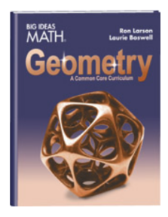How to access your textbook when [www.clever.com](http://www.clever.com) isn’t working:

1. Go to [www.bigideasmath.com](http://www.bigideasmath.com)
2. Click on “Easy Access Materials” at the very bottom of the page
3. Scroll down to where it asks “Looking for the Free Easy Access Home Edition” and click on the Click Here button
4. In the drop-down box that says “Choose Your Program,” choose Common Core High School and click Go.
5. Click on the picture of your geometry book and you’re ready to work!